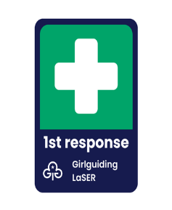 **First Response Training**

Name……………………………………………….…………………………….…… Membership Number:………………….…………..

of ……………..………………………………………………………………………..(unit) would like to attend the 1st Response training on Saturday *22nd March / 24th May / 11th October \ 2025 at Galbraith Hall, Allenby Road, Southall, UB1 2HX. (*delete as appropriate)

Contact details are: Tel: ……………………………………………………….……….

Email address: ………………………………..………………………………………..……….………

The Payment of £10 is payable on arrival or by post you should fail to attend. The amount can be paid in cash or a cheque made payable Girlguiding MSW. Important to note his is a valid expense to the unit

Return this form electronically to Jennifer Dudley – jennifer.dudley62@hotmail.com