  

**Inviting all Rainbows Brownies, Guides to a**

**Circus Skills Badge Workshop**

Saturday 21st June 2025

  

**There are 4 sessions for Rainbows Brownies & Guides to choose from**

Session 1 9.15–11.00am

Session 2 11.00am–12.45pm

Session 3 12.45–2.30pm

Session 4 2.30–4.15pm

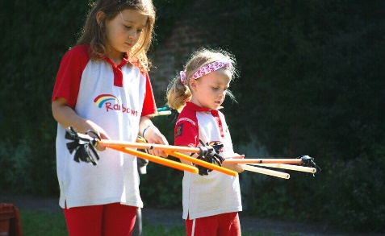

All girls will gain a Circus Skills Badge

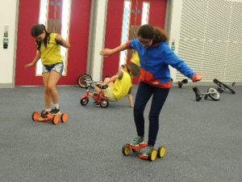 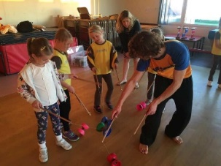

Cost £10 per Member

Venue–Galbraith Hall–Allenby Road, Southall, UB1 2HL (on the same site as Allenby Primary School)

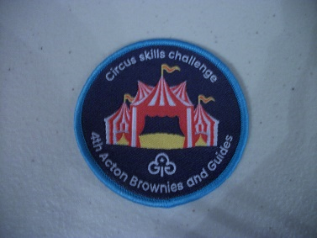

Please note numbers are limited and will be allocated on a 1st come 1st served basis. Booking forms & Payment should be returned to Jennifer Dudley -no later than **7/6/25**

**County Circus Skills Workshop at Galbraith Hall**

**Booking Form**

Saturday

21st June 2025





Unit Name _____________________________________

Leaders Name _____________________________________

There will be 4 sessions for Rainbows, Brownies and Guides when you send your booking form can you put 1st choice, 2nd choice 3rd and 4th choice

Session 1 9.15–11.00am

Session 2 11.00am–12.45pm

Session 3 12.45–2.30pm

Session 4 2.30–4.15pm

Please note A leader must be in attendance to any sessions with their young members.

Appropriate Ratios must be followed with consent forms received

A home contact needs to be identified

|  |  |  |  |  |
| --- | --- | --- | --- | --- |
| **Options** | **Time of Session** | **Cost** | **Number attending** | **Name of leaders attending with contact details** |
| 1st Choice |  | £10 |  |  |
| 2nd Choice |  | £10 |  |  |
| 3rd Choice |  | £10 |  |  |
| 4th Choice |  | £10 |  |  |
| Method of payment (cash, cheque, County BACs)  Delete as appropriate | | | Amount Paid |  |
|  |
| Cheques made payable to Girlguiding Middlesex South West | | | |  |
| BACS payment Girlguiding Middlesex South West  Account Number 81419005 Sortcode 402122 Reference Circus Workshop | | | | |

Please note numbers are limited and will be done on a first come first served basis. Booking forms should be returned to Jennifer Dudley no later than **7th June 2025**